**O’Casey, Sean (1880-1964)**

Born into Dublin tenement life in 1880, Sean O’Casey (originally John O’Casey) went on to become one of Ireland’s most important playwrights, best known for his realist Dublin Trilogy, which premiered at the Abbey Theatre and included *The Shadow of a Gunman* (1923), *Juno and the Paycock* (1924), and *The Plough and the Stars* (1926). The four-act *Plough and the Stars* provoked riots on its second night as protestors objected to the play’s critique of Irish nationalism. O’Casey’s close association with the Abbey ended in 1928 when W. B. Yeats rejected his play about the First World War, *The Silver Tassie*, which combined realism and expressionism. O’Casey had moved to England in 1926, where he married the actress Eileen Carey, and he continued to write politically focussed plays for English and American stages. He also wrote political essays and six volumes of autobiography.

O’Casey’s family were working-class Dubliners who struggled financially after his father was seriously injured, and O’Casey started work at age fourteen. This first-hand understanding of gruelling poverty informed his life-long socialism and his involvement in the 1913 Dublin Lockout strike. In *The Plough and the Stars*, his critique of nationalism centered on the disparity between the rhetoric of freedom through blood sacrifice and the hardships of working-class life. In *The Silver Tassie*, he foregrounded the realities of working-class life again, this time against the backdrop of the First World War. Yeats and Lady Augusta Gregory rejected *The Silver Tassie* for the Abbey because of its stylistic experimentation and O’Casey’s lack of first-hand knowledge of the trenches, to which O’Casey responded, ‘Does war consist only of battlefields?’ (*Letters*, vol. 1, 271-3). The play was produced in London in 1929 and finally received a short run at the Abbey in 1935. Although controversial in the 1920s, the Dublin Trilogy became one of the Abbey’s most profitable and in-demand productions in the 1930s and 40s.

O’Casey’s later works include *Within the Gates* (1934), about the tradition of Speakers’ Corner in London’s Hyde Park; the play was produced in London and New York, where he met Eugene O’Neill. O’Casey also continued to write drama informed by political concerns, including *The Star Turns Red* (1940), *Red Roses for Me* (1943), *Purple Dust* (1943), and *Cock-a-Doodle Dandy* (1949). These plays sustained his formal experimentation and exploitation of the disruptive potential of comedy.

O’Casey struggled with his work being banned, both in Ireland and elsewhere. In 1939, the first volume of his autobiographies, *I Knock at the Door*, was banned in Ireland due to its frank sexual content. When his play *The Drums of Father Ned* had its production shut down under duress from the Archbishop of Dublin in 1955, he responded by refusing any further production of his plays in Ireland, a ban which he only lifted in 1964, the year of his death.

**List of Works**

O’Casey, Sean. (1980) *Autobiographies*, 2 vols., London: Pan.

----- (1951) *Collected Plays*, 4 vols., London: Macmillan.

----- (1975) *The Letters of Sean O’Casey*, 4 vols., ed. David Krause, London: Macmillan.

----- (1998) *Three Dublin Plays*, London: Faber and Faber.

**References and Further Readings**

Kilroy, Thomas. (ed.) (1975) *Sean O’Casey: A Collection of Critical Essays*, London: Prentice-Hall.

Krause, David. (1979) *Sean O'Casey: The Man and his Work*, London: Macmillan.

Krause, David, and Robert G. Lowery. (eds.) (1980) *Sean O’Casey: Centenary Essays*, Gerrards Cross: Colin Smythe.

Moran, James. (2013) *The Theatre of Sean O’Casey*, London: Bloomsbury Methuen.

Murray, Christopher. (2006) *Sean O’Casey: Writer at Work*, Dublin: Gill and Macmillan.

**Emilie Pine, University College Dublin**

**Recommended Illustrations**

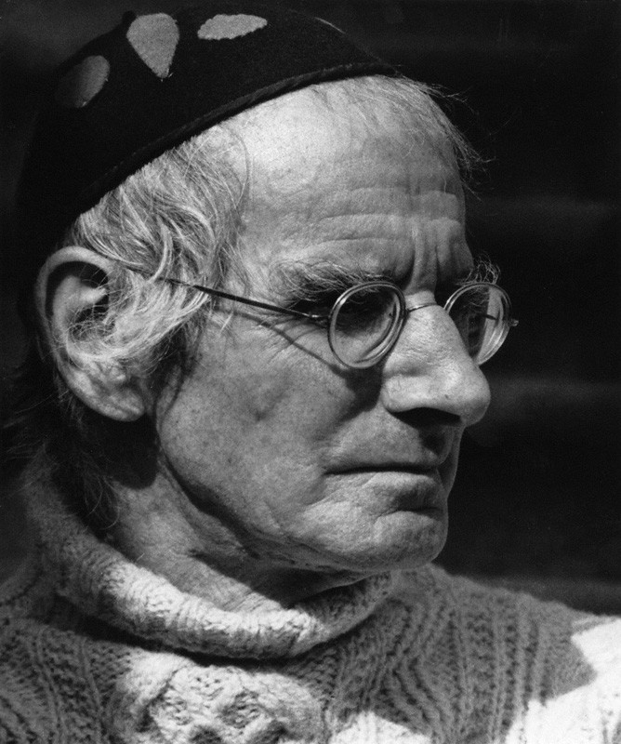

**Sean O’Casey**

[Available at: <http://www.npg.org.uk/collections/search/portraitLarge/mw07743/Sean-OCasey> ]

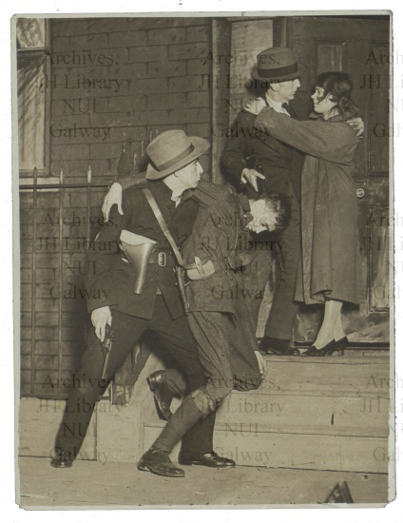

***The Plough and the Stars*, Abbey Theatre, 1926.**

[Available at National University of Ireland, Galway:

<http://archives.library.nuigalway.ie/Guide/arts.html> ]

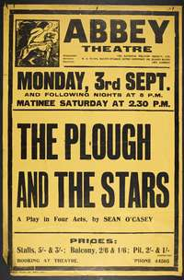

**Poster for the Abbey Theatre’s 1934 production of Sean O’Casey’s *The Plough and the Stars*.**

[Available at the National Library of Ireland: <http://catalogue.nli.ie/Record/vtls000253409> ]